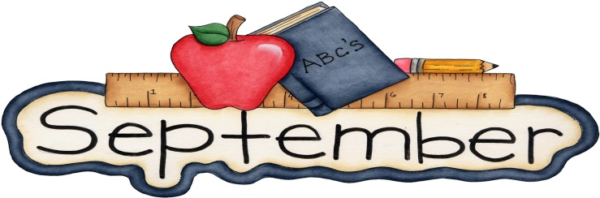
Class News | Notes/Reminders
What we are learning: 9/8/17  September Unit:  Government- We have rules and laws  Reading/L.A.: Letter/sound recognition and blending, sight words – word families, story comprehension, key ideas with details  Writing: Letter/word handwriting,  Using uppercase and lowercase, using complete sentences with correct punctuation  Math: Number sense, single digit addition/subtraction, subtraction with regrouping, calendar, coin recognition, shapes, sorting, graphing and time  Social Studies: We will be exploring different school and community rules.  Science: Scientific method | - Highlights of our week:  The students loved our new Friday activity. We will be doing a recipe each Friday. We made funfetti dip this week.  - Class Dojo: If you sign up for this, you can see your child’s points and pictures of our activities. Please let me know if you need the instructions again.  - Snack  -The school sells ice cream daily for .50.  -You are welcome to send a snack from home.  -If your child does not have a snack, I will continue to provide one.  - Pictures: Please return pictures or picture money by 9/15.  As always, if you have ANY questions or concerns, please don’t hesitate to contact me….  hannahbrinson@pickenscountyschools.org  school: (706) 253-1880 personal: (706) 273-1458
Upcoming Events | High Frequency Words:
9/11-Parent Academy 6:00  9/18-9/22- Fall Break/No School | can try help good school says

