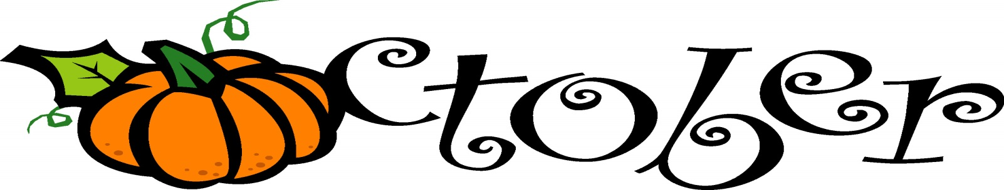
Class News | Notes/Reminders
What we are learning:10/20/17  October Unit:  Physical Science: Motion and Movement  Reading/L.A.: Letter/sound recognition and blending, sight words – word families, story comprehension, key ideas with details  Writing: Letter/word handwriting,  Using uppercase and lowercase, using complete sentences with correct punctuation  Math: Number sense, single digit addition/subtraction, subtraction with regrouping, calendar, coin recognition, shapes, sorting, graphing and time  Science: Students will be learning about how things move (push/pull) and how to describe that movement (fast/slow). | - Class Dojo: If you sign up for this, you can see your child’s points and pictures of our activities. Please let me know if you need the instructions again.  - Pictures: Please return pictures or picture money!  As always, if you have ANY questions or concerns, please don’t hesitate to contact me….  hannahbrinson@pickenscountyschools.org  school: (706) 253-1880 personal: (706) 273-1458
Upcoming Events | High Frequency Words:
10/30-11/3- Book Fair!  10/31-Doughnuts for “Dudes”  11/3- Picture Retakes | pull things move around really fast

